Journal: Methods in Ecology and Evolution

Title: **The use of computer recognizer data to assess habitat use and occupancy of understory protection harvest areas by Brown Creepers, *Certhia americana***

Connor Charchuk1

1Department of Biological Sciences, University of Alberta, Edmonton, AB Canada

* Correspondence and current address:

Connor Charchuk, Department of Biological Sciences, University of Alberta, L1-199 CCIS, Edmonton, Alberta, T6G 2E9, [ccharchu@ualberta.ca](mailto:ccharchu@ualberta.ca)

KEYWORDS

ABSTRACT

INTRODUCTION

Estimating species’ population demographics and habitat associations are intimately linked objectives in conservation biology. Increasingly, a single model is used to derive estimates for habitat-abundance associations, which are then extrapolated to estimate abundance over a larger spatial scale. Resource selection functions (RSFs) were originally designed to predict habitat selection by a species, and have since been expanded upon to estimate abundances (cite). Similarly, occupancy models have been a long-standing approach to estimating population density and abundances from occurrence data at sample locations, but have recently been applied in habitat-modelling frameworks.

Perhaps the most common application of occupancy models is with avian point count surveys to estimate population sizes for many species. Point count surveys rely on aural detection of species at survey locations on the landscape over repeated visits. The potential for an individual being present at that location but going undetected at any given visit is governed by two processes: 1) the individual was available for detection but the observer failed to detect the cue; or 2) the individual did not produce a detectable cue. MacKenzie et al. (2002) was the first to recognize this issue in point-count surveys, and developed a detection-corrected occupancy modelling (DCOM) approach to account for imperfect detectability. DCOMs use a logistic regression model to estimate the effect of environmental covariates on the probability that a species occurs at a given point location, while simultaneously estimating detection probabilities that are less than 1.

The ability for occupancy models to provide an unbiased estimate of occupancy rates has been tested extensively using simulation studies (cite multiple examples). However, an assessment of the ability for occupancy models to correctly estimate habitat-occupancy relationships is lacking (cite?). As these models are being increasingly used to predict abundances based on extrapolations (examples?), it is essential to assess their ability to provide accurate estimates of habitat-occupancy associations. Even within the scope of a study, habitat-occupancy associations may be used to draw inferences about the effects of land uses on different organisms (examples?). Interpretation of incorrect predictions derived from these models may lead to inappropriate management decisions.

In order to test the efficacy of DCOMs, it is necessary to derive models based on true occupancy rates without the potential bias of detectability. Any occupancy model which does not account for detectability by assuming perfect detection can be referred to as a naive occupancy model (NOM). The use of NOMs were prevalent in the literature prior to the development of DCOMs (cite some examples), but have been steadily replaced in response to a better understanding of the biases suffered by failing to meet the assumption of perfect detectability (cite). Imperfect detection is the result of insufficient sample effort at each survey location. The majority of individual species monitoring is conducted at large temporal and spatial scales, so acquiring sufficient sampling effort at each survey location to relax the assumption of perfect detection required to use NOMs is infeasible. For example, most bird surveys are conducted two to four times throughout a season, and at three- to ten- minute intervals at each visit. Therefore, conclusions about the species present at that location are derived from just six to forty minutes of survey data. This limitation is largely due to the cost of sending experienced observers to the same survey location repeatedly.

Recent technological advances have been made in avian point count surveys that may provide a unique opportunity to build occupancy models that sufficiently meet the assumption of perfect detectability. Passive acoustic monitoring (PAM) is increasingly used to remotely survey and monitor species, usually via the use of autonomous recording units (ARUs). Much work has been done in recent years to assess the ability of ARUs to attain survey data similar in quality to that obtained by human observers in-the-field (cite examples). Currently, the processing of ARU data generally requires a human observer to listen to the audio data to identify species vocalizing in each recording (cite). Therefore, the number of visits to each survey location is rarely improved through the use of ARUs. However, recent advances in automatic species identification may provide researchers with the ability to amass orders of magnitude more data than was previously possible (cite).

The development of algorithms to automatically detect and identify species (hereafter recognizers) provides the opportunity to amass substantially more species-location data than was previously available. Increases in species data could be used to improve estimates of local abundance and species-habitat relationships. However, these data are still being inappropriately applied to DCOMs (e.g. Campos-Cerqueira & Aide 2016). DCOMs were established for surveying protocols with low sample effort where the probability at any survey location of *failing to ever detect an individual* *throughout the survey period* is relatively high (cite). Therefore, a location where the species was *ever* detected is assigned a ‘1’ as occupied, and locations where the species was *never* detected is assigned a value ‘>0’ as not-detected but there is some non-zero probability of occupancy. Thus, the utilization of automated species recognition data in an occupancy framework requires the implicit assumption that the algorithm failed to detect any singing event of the target species across the entire duration of recordings even though an individual of that species was occupying that location. With logical sampling design decisions, such as surveying during the season of peak vocal activity and accruing sufficient acoustic data, we argue this assumption will be violated more readily than the assumption that if the location was occupied, the algorithm would detect that individual at least once during the duration of the survey. The only lasting assumption is thus that occupancy estimates and inferences are constrained to the extent of the survey period, which was established by MacKenzie (2006) and, by extension, L. L. McDonald.

Quantification of habitat occupancy rates are often a desired measure in assessing human land use impacts. Timber harvesting represents one of the predominant human land-use effects on habitat for many forest songbird species (cite). Avian point count surveys have been used extensively in conjunction with DCOMs to test the effects of different harvesting procedures on occupancy rates of various species (cite some examples). The magnitude and direction of the response to forest harvesting is highly species-dependent (Titterington *et al.* 1979). Therefore, deciding which species to assess for sustainable harvesting practice requires *a priori* understanding of that species’ habitat requirements to test specific hypotheses of the effects of forestry. One species that has consistently emerged in the North American literature as a candidate indicator species for forestry impact assessment is the brown creeper *Certhia americana*. Brown creepers have been identified as the species most dependent on old forests (Schieck and Nietfeld 1995) and the species most sensitive to forest harvesting (Vanderwel et al. 2007). In Alberta, brown creeper populations are declining (cite), potentially due to an increasingly younger forest caused by forest harvesting.

Brown creeper habitat preferences and responses to forest practices have been well established in the literature. Adams and Morrison (1993) employed high-effort field observations to assess year-round brown creeper habitat selection, and were the first to acknowledge the potential negative impacts of timber harvesting on this species. Work in the last decade has placed an increasing emphasis on brown creeper sensitivity to forestry. Poulin et al. (2008) suggest the conservation of breeding populations of brown creepers is incompatible with harvesting at even the lowest intensities. D’astous and Villard (2012) show that harvesting with high levels of retention resulted in a halving in brown creeper nest densities, likely due to a decline in forage availability. Vogeler et al. (2013) used LiDAR-derived estimates of forest structure and emphasized the importance of tall canopies in maintaining brown creeper populations. Finally, Geleynse, Burke and Elliott (2016) show that brown creeper density declined in three retention harvesting strategies relative to unharvested controls, though they lacked the sample size to detect significant differences (3 replicates per treatment). Brown creeper sensitivity to forest management thus provides perhaps the best opportunity to assess the sustainability of novel harvesting strategies for mature forest species.

In Alberta, Canada, a recent harvesting practice known as understory protection has emerged that shows some promise for preserving habitat for species that depend on mature forests to breed (Charchuk & Bayne, unpublished). Understory protection harvesting (UP) seeks to protect young white spruce during hardwood harvest for future softwood harvesting. Previous research has shown that white spruce freed from competition in these situations can experience elevated growth rates by up to 350% (cite), thus these harvest blocks may be able to provide habitat to mature forest species very soon after harvesting occurs. Furthermore, a small portion of the mature timber in these harvest blocks is retained to protect the understory from windthrow, which may also contribute potential habitat. Studying the brown creeper response to understory protection harvesting is essential to understanding the habitat that UP harvest blocks provide and directing future management practices. The goal of this research was to develop an automatic computer recognition algorithm for brown creepers to accomplish two goals. First, to assess the habitat use and occupancy rates of understory protection habitat relative to nearby mature forests by brown creepers; and second, to assess the ability of DCOMs derived from standard point count data to accurately estimate occupancy rates and species-habitat relationships.

METHODS

The study was conducted on lands managed by Alberta Pacific Forest Industries Inc. (hereafter Al-Pac) in the boreal forest of Alberta, Canada. Data for this project was repurposed from a previous study on the effects of understory protection harvesting on bird communities. For a detailed description of the surveying methods see Charchuk and Bayne (201X). The project herein relies solely on data collected in 2016 due to different recording schedules between 2015 and 2016. We surveyed 39 understory protection harvest blocks, though only included the 25 sites that were cut after the LiDAR data was flown. We included all 39 unharvested control sites in this analysis. Bird surveys were conducted between May 25 – July 4 when brown creepers are most vocally active during the breeding season. Survey locations were based on no prior knowledge of brown creeper locations and were deployed based on a separate study design purpose.

Bird surveys were conducted using autonomous recording units (ARUs) developed by Wildlife Acoustics. We deployed a single ARU to each harvest block and control site to collect acoustic data over a 3-4 day period. Acoustic recordings from the ARUs were processed manually in the lab by experienced observers with expertise identifying birds in Alberta’s boreal forest. Listening involved transcribing all species heard vocalizing during three-minute surveys between 4:30am-5:30am when songbirds are most vocally active during the day. A minimum of four recordings were processed from each site, on separate days whenever possible. Thus, each site has 12-minutes of acoustic data processed. Recordings with high wind or rain were not processed to maximize detectability; therefore, sometimes two recordings from the same day were processed. Recordings were processed in Adobe Audition or Audacity, and visualization of the spectrogram was used in concurrence with listening to identify all vocalizing species. Multiple individuals of the same species were identified whenever possible using cues such as differential sound strength on the left versus right channel or the occurrence of overlapping signals from the same species.

Environmental covariates were extracted for each ARU using a buffer size of 50m: the distance at which we estimate brown creepers can be reliably detected given their quiet high-frequency song (~4200-7100Hz). Covariate buffer size is thus based on acoustic detectability rather than territory size, which is estimated between 5-10 hectares (Poulin et al. 2008). LiDAR data was averaged across the buffer for each covariate using zonal statistics in ArcMap. We extracted LiDAR data for the canopy height (P95), the average proportion of returns between 1.37-5m (S137to5), the average proportion of returns between 5-10m (S5to10), the average proportion of returns between 10-20m (S10to20), and the average proportion of returns between 20-30m (S20to30). We tested the effects of forest age for both the understory protection (UP) and unharvested forest controls (FC) and allowed this term to interact with our harvest treatment effect because age effects are expected to be different for the UP blocks than for the FC stands. Deployment date was also tested to account for seasonal variation in brown creeper singing behaviour.

We developed a recognizer for the brown creeper primary song using the SongScope software developed by Wildlife Acoustics. SongScope uses hidden Markov models to match signal patterns in observed spectrograms against training data. We built our recognizer using 92 individual brown creeper song examples recorded throughout northern Alberta using SM2+ song meters developed by Wildlife Acoustics. Cross-training was used to assess how well each individual annotation in the training data matched the final recognizer algorithm. Cross-training yielded an average score (how well the observed spectrogram matches the algorithm) of 67.4 +/- 1.63%; therefore, the average brown creeper song can be expected to yield a score of 67.4%. We set our score threshold when running the recognizer at 50% to ensure poorly matching spectrograms were also returned. The tradeoff therein is a greater effort in validating candidate detections returned by the recognizer (flags), as there is a very high false positive rate. We felt for the purpose of this study it was more important to minimize false negative rates, thus inflating our false positive rate and subsequently our human effort required in validating the flags.

The recognizer processed all acoustic data collected at each site. The ARUs recorded continuously from 4:30am-10:00am to maximize data collection at dawn when songbirds are most active, and periodically throughout the day for consistency with other monitoring programs in the area (Table X). In total, each ARU day is equal to 361 minutes of acoustic data, and each site had 3 or 4 ARU days of data; therefore, the recognizer processed 1083 or 1444 minutes of data at each site. All flags returned by the recognizer were validated by an experienced technician by listening to each clip or visually confirming the spectrogram to confirm true positives (hits).

First we developed a model for the brown creeper habitat use, using recognizer data with each unique hit representing a data point. Using each detection as a data point allows sites with more brown creeper detections to represent higher use; therefore, covariate values at these locations will drive the species-habitat associations. We fit a logistic regression model with the cloglog link because the data is derived from a censored poisson distribution: we only know if there is 1 brown creeper or 0, but is derived from a Poisson distribution where counts from 0 to infinity are possible. Replicating each hit as a separate data point allows sites with higher use by brown creepers to have a stronger influence on the habitat modelling. However, this makes the interpretation of λ the predicted degree of use of habitat *if* it is occupied by a brown creeper, rather than probability of occupancy. Thus, values of 1 represent the highest degree of use, values close to 0 represent a small proportion of use, and absolute 0 represents unoccupied sites. We used forward AIC step selection to derive the final model; additional parameters were only added to the model if it improved the model fit by ≥2 ∆AIC. Once a final model was derived, we applied the same covariates to an occupancy framework, with all covariates going on the occupancy side of the equation.

Next, we developed a brown creeper occupancy model from the recognizer data assuming perfect detection. Sites with at least one hit (i.e. detection) were assigned a value of 1, while sites that never had a brown creeper were assigned a value of 0. Again, a logistic regression model with the cloglog link was fit, using forward AIC step selection to derive the final model. Model coefficients can be interpreted in the context of the probability of that site being occupied by at least one brown creeper.   
 We tested the MacKenzie (2002) model of estimating occupancy rates when detectability is less than one because it is a well cited and extensively employed method. The model was built using the “occu” function in the package unmarked. The DCOM was built using detection data collected from human point count surveys derived from ARU recordings (hereafter listening data). Listening for this project was conducted in a way that is very similar to other avian point count surveys. We used four visits to each site which results in a detection history length that is similar to many other studies. We were interested in testing two components of DCOMs:

1. The ability for DCOMs to accurately estimate true occupancy rates; and
2. The ability for DCOMs to accurately describe habitat associations

To test if occupancy models could approximate true occupancy rates and covariate effects on occupancy, we compared occupancy rates derived from a DCOM to the recognizer derived occupancy (RDO) model using the covariates from the RDO model. All covariates were designated to the occupancy side of the model and detectability was left as the intercept value. To test if occupancy models could disentangle effects on degree of use, we compared habitat relationships derived from a DCOM to those from the recognizer derived use (RDU) model using the covariates from the RDU model. Again, all covariates were designated to the occupancy side of the model and detectability was left as the intercept value.

RESULTS

*Listening vs. Automated Recognition Detection*

Human listening detected brown creepers at 12/38 control sites and 0/25 understory protection sites. Automatic computer recognition detected brown creepers at 27/38 control sites, and 4/25 understory protection sites. Therefore, our true occupancy rates based on the recognizer data are 0.711 in old growth sites and 0.16 in understory protection sites. On days where human listening was conducted, there were no instances where humans detected brown creepers but the computer recognizer did not; in contrast, out of 81 independent days with detections of brown creepers, 58 (72%) were detected exclusively by automatic recognition.

*Recognizer Derived Use Model*

Forward AIC step selection resulted in the following final model for the RDU model (Table X):

*Hit ~ Treatment + P95 + S137to5 + S10to20 + Treatment*P95*

Overall, brown creepers used unharvested forests much more than the understory protection. If a site was occupied, the average degree of use of old growth sites was 0.974 and for understory protection was 0.735. The treatment and canopy height main effects are non-interpretable due to the interaction, for which an effects plot was made to illustrate the interaction effect (Figure X). In the unharvested controls, brown creeper use increased with increasing canopy height; but in the understory protection blocks, brown creeper use decreased with increasing canopy height.. The proportion of returns between 1.37m and 5m represents the density of understory vegetation, which had a negative effect on brown creeper use (β=-5.667, p=0.0031). The proportion of returns between 10m and 20m represented the density of moderate height trees, and had a strong positive effect on brown creeper use (β=4.544, p=8.58*x*10-8, Figure X).

In order to compare the results of the RDU to the occupancy model, we converted beta coefficients back into the ordinal scale (λ). An increase in the proportion of returns between 1.37m and 5m resulted in a 0.0035 times increase in use by brown creepers, while an increase in the proportion of returns between 10m to 20m resulted in a 1 times increase in the use by brown creepers.

*Recognizer Derived Occupancy Model*

Forward AIC step selection resulted in the following final model for the RDO model (Table X):

*Occupancy ~ Treatment + P95 + Treatment*P95*

The average predicted occupancy rate for Brown Creepers was 0.707 in old growth forests and 0.155 in understory protection blocks. The model predicted that brown creepers would reach their maximum abundance in the unharvested controls at the highest canopy height, but in the understory protection at the lowest canopy height (Figure X). Surprisingly, brown creeper predicted abundance was predicted to approach 1 at a canopy height of 30m in the old growth forests. This asymptote alludes to the perfect detection in our study using recognizers, because otherwise even in ideal habitat, predicted occupancy should be less than 1 due to detection error.

*Listening Occupancy Model – Habitat Modelling*

First we modelled the human listening data using the covariates derived from the RDU model using the MacKenzie (2002) detection-corrected occupancy modelling (DCOM) approach. This model took the form:

*~1 ~Treatment + P95 + S137to5 + S10to20 + Treatment*P95*

where ~1 is the intercept value for the detection process.

The predicted detectability in this model was 0.442 +/- 0.149. The average predicted occupancy rate in the unharvested controls was 0.315 +/- 0.269 and in the understory protection treatment was 0.122 +/- 0.345 (Figure X).

The interaction between canopy height and treatment was positive and not significant (β = 0.006, p = 0.984). We plotted predicted values of occupancy rates in response to canopy height for control and understory protection sites (Figure X) which showed a similar positive response of occupancy to canopy height in the understory protection sites and control sites.

What about the effect of the understory density? The proportion of LiDAR returns between 10-20m had a moderate effect on occupancy rates (β = 4.55, p = 0.240), and the effects plot shows that both understory protection and unharvested controls respond positively to increasing densities of mid-height trees (Figure X). A one-unit change in the proportion of returns between 10-20m thus increased the probability of occupancy by 94.6 times.

*Listening Occupancy Model – Occupancy Modelling*

We modeled the effects of the covariates derived from the RDO model on the listening data using the MacKenzie (2002) DCOM approach. The model took the form:

*~1 ~Treatment + P95 + Treatment* P95*

where ~1 is the intercept value for the detection process.

The probability of detection in this model was 0.443 +/- 0.149. The average predicted occupancy rate in the control sites was 0.313 +/- 0.110 and 0.177 +/- 0.106 in the understory protection treatment. Estimates of occupancy were similar to the full model, but the confidence intervals were greatly reduced. The 95% confidence interval for predicted occupancy rate in the unharvest controls was 0.203 - 0.423, whereas the true occupancy rate from the recognizer data was deemed to be 0.711. The 95% confidence interval for predicted occupancy rate in the understory protection blocks was 0.071 - 0.283, with the true occupancy rate from the recognizer data being 0.16.

The interaction between treatment and canopy height remained weakly positive (π*x* = 1.09, p = 0.677). We plotted predicted means to visualize the interaction effect, which showed a slight positive response of predicted occupancy in response to canopy height in understory protection sites, but no response in control sites (Figure X).

DISCUSSION

*Brown Creeper Habitat Use - RDU*

Brown creeper habitat use was strongly influenced by both the harvesting treatment and canopy height. Unsurprisingly, brown creepers showed much higher use of unharvested controls than understory protection habitat. We interpret this result to suggest creepers will incorporate the UP harvest block into their territory but will not use it exclusively. The UP may therefore have weaker effects on densities than other harvesting strategies, but Poulin and Villard (2011) showed a reduction in nest success in brown creepers whose nests were located closer to the forest edge. Further work could expand on our results to investigate demographic effects caused by UP harvest blocks in a managed forest landscape.

Brown creeper response to canopy height was shown to be dependent on the treatment type. Previous literature has established that taller canopies are associated with higher occupancy rates in brown creepers (Vogeler et al. 2013), which held true in our control sites. However, predicted brown creeper use of understory protection sites showed a precipitous decline as canopy height increased. We interpret this result to be a function of the type of trees present in the canopy. Brown creepers have been shown to be highly dependent on mature conifers for foraging and breeding sites (Adams and Morrison 1993), and specifically white spruce (*Picea glauca*)in western Canada (ASRD 2003). The canopy in mature forests in this region are dominated by conifers, thus it is unsurprising that brown creeper habitat use increased with increasing canopy height in our control sites. In contrast, the canopy of understory protection sites is dominated by the mature aspen (*Populus tremuloides*) left in the retention strips (Navratil et al. 1994; Grover et al. 2014). Brown creepers have been shown to respond negatively to increasing densities of mature deciduous, which is consistent with this interaction (cite). Therefore, the height of canopy is not a good predictor for brown creeper use in understory protection habitat.

Brown creeper habitat use was strongly negatively associated with the proportion of LiDAR returns between 1.37m and 5m. This height range represents the majority of shrubs and undergrowth vegetation, suggesting brown creepers prefer habitat with a less developed understory. Our results contradict previous research that suggested brown creepers are positively associated with shrub density (Schieck and Nietfeld 1995), though they performed a community analysis using canonical correspondence analysis and thus could be a spurious effect of other environment-species drivers. Our analysis represents the first study we are aware of to utilize LiDAR-derived understory structure to predict habitat preferences by brown creepers.

Our model revealed that brown creeper habitat use was positively associated with an increasing density of trees between 10-20m. This result is consistent with the findings of Vogeler et al. (2013) who found that the average canopy height associated with occupied creeper sites was 12.17m +/- 1.12m. Furthermore, our results show the degree of use of control sites showed the strongest rate of increase at around 15-20m, suggesting this is a critical threshold tree height necessary to support brown creepers. However, brown creeper habitat use continues to increase up to 30m, suggesting that old forests with canopies taller than 10-20m may represent higher quality habitat. The density of trees in the 10-20m range showed little effect on brown creeper habitat use in unharvested forests, likely because canopy height is the stronger driver in these sites. In contrast, the density of 10-20m tall trees resulted in a strong increase in brown creeper use of understory protection sites. We interpret this as the response of brown creepers to the rapidly regenerating spruce understory. Previous studies have shown that the understory white spruce, when freed from competition in understory protection patches, can increase in growth rate by up to 350% (Lieffers and Grover 2004). Grover et al. (2014) measured the average height of protected white spruce trees to be 10m in understory protection sites at the time of harvest; therefore, even a conservative estimate of growth rates would suggest that these trees are reaching sizes capable of supporting brown creepers within just a few years post-harvest. Furthermore, much of our LiDAR data was collected 8-10 years prior to surveying; thus, trees measured in the 10-20m range were likely much taller at the time of surveying. Ultimately, we show that the white spruce protected in understory protection harvesting is capable of supporting low densities of brown creepers almost immediately post-harvest.

*Brown Creeper Occupancy – RDO*

Building an occupancy model using recognizer data without accounting for imperfect detection resulted in a similar conclusion to the habitat use model regarding habitat preferences. Forward AIC step selection resulted in a model with an interaction between treatment and canopy height as the strongest predictor of brown creeper occupancy. The direction and strength of this interaction (Figure X) was similar to that described from the habitat use model (Figure X). This suggests that occupancy models derived from recognizer data are capable of approximating habitat use models. Most interestingly, our model predicted a maximum occupancy rates of 0.995 in unharvest controls with tall canopies. Our interpretation of this value is an estimation of our detection probability: in ideal habitat where brown creeper is expected to occur, we have a 99.5% probability of detecting one. However, this value is associated with very high standard error (0.543) and thus may not be a reliable estimate of detectability.

The occupancy rates estimated by our model were almost identical to the true occupancy rates in our system. The model predicted an average occupancy in old growth sites of 0.707, compared to an observed value of 0.711. The average occupancy in understory protection sites was 0.155, compared to a true value of 0.16. Therefore, modelling occupancy without accounting for detectability is not only able to correctly estimate habitat use, but also provides accurate estimates of true occupancy rates. There was a significant amount of error associated with these estimates, likely due to small sample size, though the accuracy of the estimates suggests that the model will predict unbiased estimates of true occupancy rates.

*Detection-corrected Occupancy Modelling*

The DCOM derived from habitat use covariates in our study failed to correctly predict creeper-habitat associations. The interaction effect between harvest treatment and canopy height was insignificant, and showed a similar positive relationship in both the understory protection and controls. In fact, the DCOM model predicted a slightly stronger relationship with canopy height in understory protection habitat; resultantly, the model predicts brown creeper occupancy in understory protection to overtake old growth forests when the canopy reaches >28.2m. [discuss habitat associations further]. Furthermore, the DCOMs were unable to detect the interactive effect between canopy height and forest type on creeper occupancy. From a management perspective this result would be misinterpreted to suggest that harvesting in a way to maintain taller canopies in understory protection blocks would facilitate greater use by brown creepers. However, this would potentially have a negative effect on brown creeper occupancy because taller aspens would be retained and would outcompete the developing white spruce that the creepers depend on.

The DCOM model derived from the RDO model underestimated old growth occupancy but accurately estimated understory protection occupancy. These results suggest that DCOMs may be effective at estimating occupancy rates when true occupancy rates are low, but fails to account for species movement throughout the survey period. Surprising, our DCOM was able to correctly estimate occupancy rates in the understory protection despite no detections of brown creeper existing in the data. This result likely speaks to the ability for DCOMs to utilize detectability rates to correctly estimate occupancy rates when occupancy rates are low.

The inability for the DCOM to estimate the true occupancy rates in the unharvested controls is likely due to the movement of brown creepers in and out of the ARU detection radius. The repercussions of the closure assumption of occupancy models being violated has been discussed previously (cite), but here we use real data to show the consequences of its violation. Underestimating population sizes is hard to imagine as a negative consequence of DCOMs from a conservation perspective; however, it is the application of these models to habitat modelling is where this becomes problematic.

The increasing application of occupancy models to, inappropriately, habitat modelling frameworks needs to be addressed. Occupancy models were first derived to estimate population trends, but it is only recently that researchers have been utilizing the covariates in these models to predict suitable habitat and extrapolate beyond the spatial bounds of their study. Our data show that a substantial proportion of old growth sites in our study would be identified as unsuitable habitat for brown creepers following the interpretation of the DCOMs. One potential repercussion of misidentifying patches as poor quality habitat for an at-risk species is the decision to remove that forest patch via forestry practices or other human land-use disturbances. Ultimately, we recommend caution when interpreting the results of an occupancy model that corrects for imperfect detection, as these models cannot reliably estimate species-habitat associations and should only be used as conservative estimates of abundance.

Our ROM model was able to accurately predicted occupancy rates for the old growth and understory protection habitats; while DCOMs failed with the former. Ideally, we would attempt a bootstrap estimator on our dataset to accurately estimate the model performances, but as is frequently the case with this kind of data, we lacked the sample size necessary to do so effectively. Further testing of ROMs in their ability to produce unbiased estimates of occupancy is an important next step in accepting these models in practice. Our model results show that DCOMs were unable to reproduce both the effects of habitat use and occupancy rates by brown creepers in this study.

*Automatic Computer Recognition*

Increasingly, autonomous recording units are being used to conduct bird surveys across North America (cite); however, ways of dealing with the wealth of data that are collected by these units is lagging behind. Automatic computer recognition software showed great promise in this study at using pattern matching algorithms to detect and identify bird songs. As these technologies are improved and increasingly implemented, it is important to establish ways of dealing with this new kind of data. Traditional bird survey data is challenged by small sample size and imperfect detection of target species (cite), but computer recognition software may be able to overcome both these limitations (cite). It is our position that reducing the data generated by computer recognizers into a format that is amenable to existing modelling approaches is not ideal, and a substantial amount of information is lost. Here we develop for the first time a straightforward modelling procedure to handle recognizer data to estimate both occupancy rates and habitat associations more accurately than existing methods.

Using each detection of a song at a given location as an independent replicate in a modelling framework allowed us to model the degree of habitat use by brown creepers. We interpret the probability ratio in this model as *the unit increase in the probability of use as a function of a unit increase in x.* Therefore, this model is strongly influenced by sites that are occupied and used to varying degrees by brown creepers, and unoccupied sites have little influence on the resulting habitat model. Sites with more detections are inferred to be used more frequently; in order to make this inference we must make the assumption that the detection process is the same between sites (i.e. the species is equally detectable by the recognizer at each site). While this assumption likely does not hold true, the relationship between use and number of hits is likely strong enough to overcome biases in the detection process. We recommend further testing of this assumption using field methods.

Recognizer data can be readily condensed into a format that is amenable to occupancy modelling, though we recommend against traditional modelling approaches that assume imperfect detection. DCOMs require a discretized detection history of detections and non-detections, but automatic recognition provides a pseudo-continuous representation of presence. Therefore, periods of non-detection are likely the result of the species moving out of the detection radius of the sampling unit, or not producing detectable signals (i.e. is not singing, and therefore not actively defending territory), rather than the result of the species being present and vocalizing but the recognizer failing to detect it. Thus, we feel it is more sensible to assume perfect detection with these data than it is to *ad hoc* discretize recognizer detections into a detection history whereby 0s likely represent movement out of the survey area or non-territoriality rather than detectability.

Conclusion

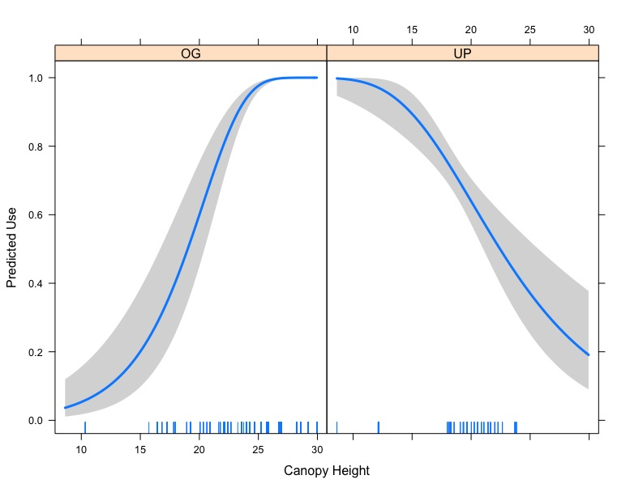

Figure X. Predicted use of Brown Creepers in old growth habitat (left panel) and understory protection (right panel) in response to canopy height (m). Predictions are derived from the recognizer hit replicated model.

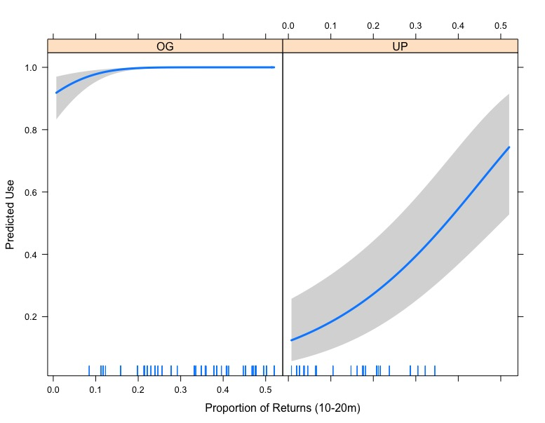

Figure X. Predicted use by Brown Creeper as a function of the proportion of LiDAR returns in the 10 to 20m height category. Separating the UP from the OG station effects illustrates that this effect is almost entirely driven by the UP sites. Predictions are derived from the HRM.

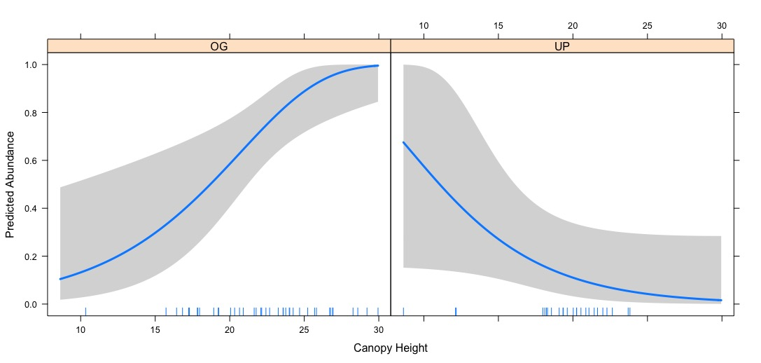

Figure X. The predicted abundance of Brown Creepers in old growth habitat (left panel) and understory protection habitat (right panel) in response to the canopy height (m). Predictions are derived from the ROM.

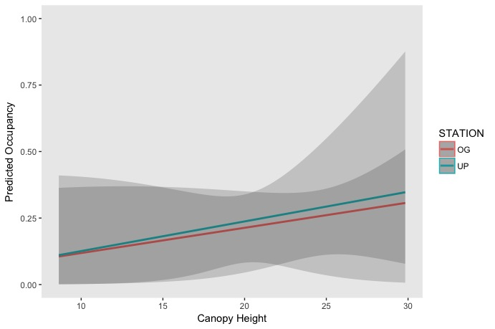

Figure X. Predicted probability of occupancy as a function of canopy height for old growth sites (red) and understory protection sites (teal). Predicted values derive from listening data DCOM with HRM covariates.

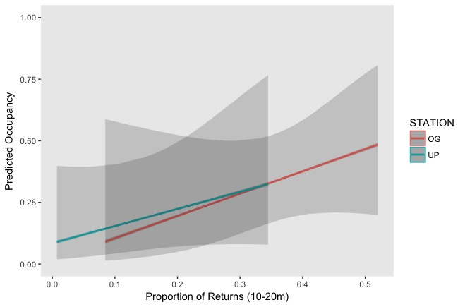

Figure X. Predicted probability of occupancy as a function of the proportion of LiDAR returns between 10-20m. Predicted values are derived from detection-corrected occupancy model of listening data

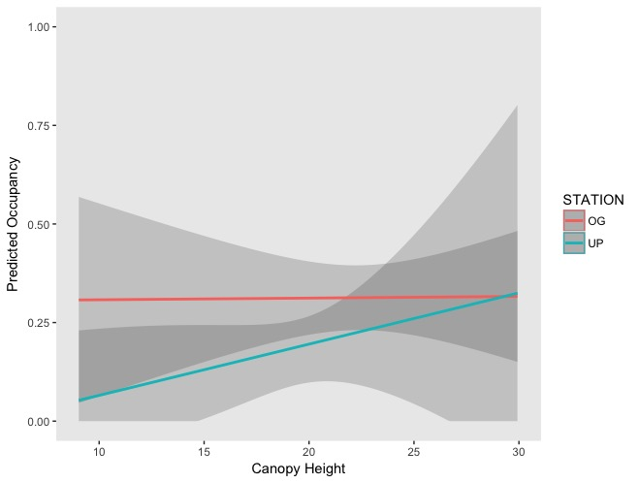

Figure X. Predicted probability of occupancy as a function of canopy height. Predicted values derive from listening data DCOM with ROM covariates.

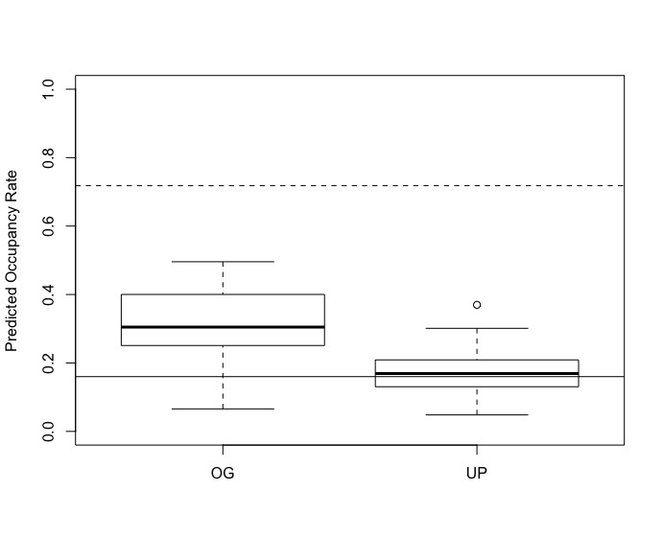

Figure X. Boxplot showing predicted occupancy rates of old growth and understory protection sites derived from full occupancy model given actual covariate values for each site. Dashed line represents true occupancy rate in old growth sites (0.718), solid line represents true occupancy rate in understory protection sites (0.16).

Table X. Forward AIC step selection process for the recognizer hit replicated model

|  |  |  |  |  |  |  |
| --- | --- | --- | --- | --- | --- | --- |
| **Model** | Treatment | +Canopy Height | +1.37-5m | + Station*Canopy Height | + 10-20m | + Deploy Date |
| **AIC** | 815.98 | 688.84 | 625.15 | 573.35 | 537.09 | 538.9 |

Literature Cited

Alberta Sustainable Resource Development. 2003. Status of the Brown Creeper (*Certhia americana*) in Alberta. Alberta Sustainable Resource Development, Fish and Wildlife Division, and Alberta Conservation Association, Wildlife Status Report No. 49.